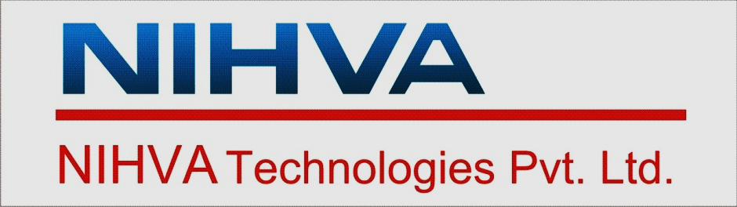

QUALITY MANAGEMENT SYSTEM MANUAL

Prepared and maintained
in accordance with
ISO9001: 2015

ISSUE 02
REVISION 03
DATE: 1 Feb. 2023

NIHVA Technologies Pvt. Ltd.

Head office
Dream house, 187-G-block, First floor
Thermax Chowk
MIDC Chinchwad, Pune 411019

Works
Gat no. 199, Jyotiba Nagar, Talawade
Pune 411062

RELEASED & APPROVED BY: M.R.

